November 25, 2014
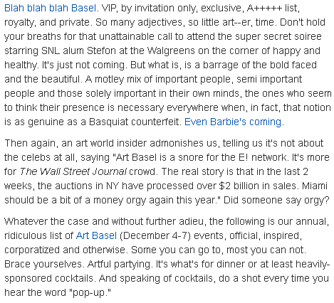
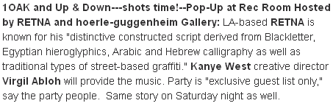
http://blogs.herald.com/scene_in_the_tropics/2014/11/an-unabridged-exhaustively-updated-guide-to-art-basel-miami-beach-parties-you-can-and-cant-get-into.html

