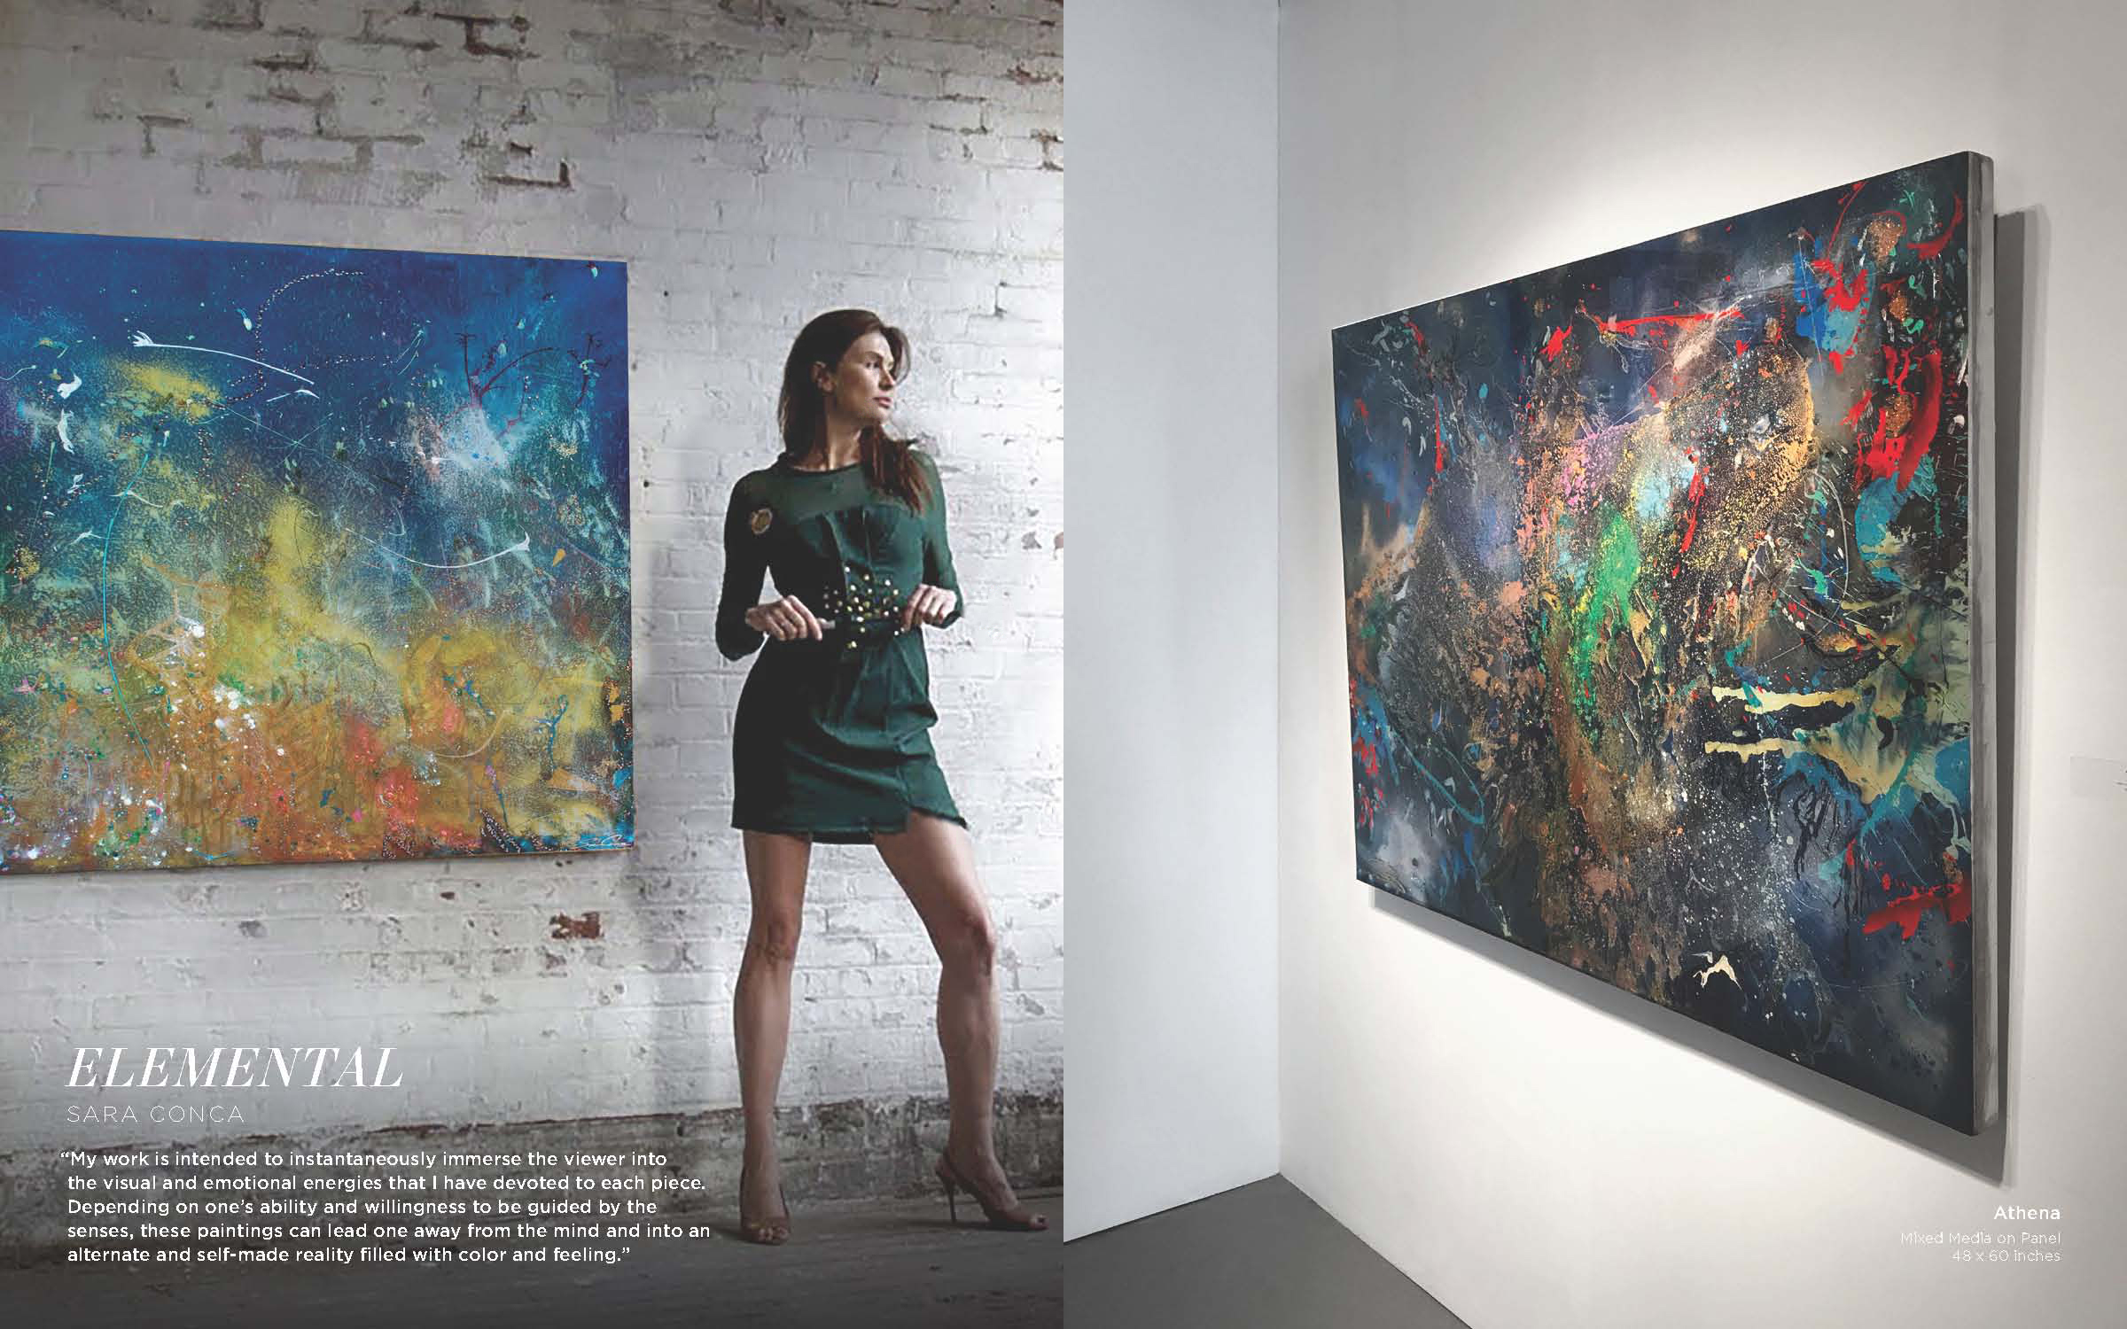

Sara Conca, is a contemporary abstract artist of Native American and French- Italian descent. She has sold her works to many collectors in Europe, Asia, and the United States. Her paintings can be found in private chateaus and hotel lobbies in France, as well as in many exclusive celebrity homes and museums.

By the age of 17, Sara was living and working in Paris. A life changing experience that reinforced her need for movement, energy and art. While in Paris, Sara studied sculpture at Ateliers D’Art De St Maur Des Fosses, and further continued her education in South Florida as an assistant of the critically lauded artist Purvis Young.
Sara Conca has spent her last 18 years in Manhattan, Living solely off her painting sales, Extensive international travels, and the influence of New York City has given her an insightful appreciation for her ever- changing environments and settings, as well as heavily influencing her.

Sara Conca has returned to her roots in Florida, which has inspired her to create a fresh new aquatic mystical series involving natural mixed media such as raw silver dust and 18k gold leafing, raw pigments colors, mica flakes and natural crystals.

“My work is intended to instantaneously immerse the viewer into the visual and emotional energies that I have devoted to each piece. Depending on one's ability and willingness to be guided by the senses, these paintings can lead one away from the mind and into an alternate and self-made reality filled with color and feeling. My new series features gold. I love working with this color because it changes in the light and I can manipulate the textures and layering; thus affording each piece movement and energy from the reflecting and refracting light.” ~ Sara Conca

Solo Exhibitions
2017 April Innate Beauty MAC FineArt
2017 Oct Art on Centre Amelia Island Fernandina Beach “Artist of The Month”
2016 June Art on Centre Amelia Island “Artist of the month”
2016 Jan Onessimo Fine Art “Catalyst” Show
2014 July SeaFair Blink Group Gallery
2012 Aug Evolve Design Gallery Woodstock NY “See Through”
2012 July Evolve Design Gallery Woodstock NY “Gold”
2012 June Able Fine Art Gallery Chelsea NY “Emmersions”
2012 March Private Showing Lyon France
2012 Feb Roy Teeluck Lo4Art NY “Red and Gold”
2011 April Belenky Brother's Gallery Soho NY “18k Gold Layered Series”
2010 April Soho D&H Gallery NY
2009 April Ted Gibson NY
2009 Jan Soho D&H Gallery Soho NY
2008 Nov Mansion Art Gallery NY
2008 April Soho D&H Gallery Soho NY
2001 Sept Le Bibloquet, NY "Body Press Series"

Group Exhibition
2018 Oct MAC FINE ART Grand Opening MAC SOHO
2018 July MAC Fine Art “ Area”
2018 June MAC FINE ART “ Women Who Paint”
2018 May Martin Gallery Charleston S.C.
2018 March MAC Fine Art “Blind Capitulation”
2017 Dec MAC Fine Art Holiday Season Preview
2017 Dec Artifact Wynwood Art Basel
2017 Nov MAC Fine Art Jupiter Opening
2017 Sept Onessimo Fall Season Preview
2017 Aug 20th Anniversary MAC Fine Art
2017 July Art Santa Fe Platform Award Winning Artists
2017 May Evolution MAC Fine Art
2017 April Vinnings Gallery Atlanta “The Viewing Room”
2017 April Art NY Redwood Media Award Winning Platform Artists
2016 Dec Red Dot Miami MAC Fine Art
2016 Nov The Martin Gallery Charleston
2016 Nov Onessimo Fine Art West Palm Beach
2016 Nov Art San Diego Redwood Media Group Platform Artists
2016 Nov Wall Street Fine Art Jacksonville “Art Republic”
2016 Oct Palm Springs Modernism Exhibit
2016 Oct Martin Gallery Charleston
2016 March MAC Fine Art “Unsettled Landscapes”
2016 March Art on Centre Fernadina Beach FL
2015 Sep Onessimo Fine Art Gallery “Season Opener”
2015 Oct Le Floch Et Le Floch Paris
2015 June Coral Springs Museum of Art “ Inspire”
2014 Dec Spectrum Art Basel Miami BlinkGroup Gallery
2014 Sept Museum of Shenandoah “Taking Flight”
2014 July Prevu Pop Up Show Blink Group
2013 Aug Percepts Gallery Lyon France
2012 Sept K.I.A.F. Able Fine Art Gallery Seoul Korea
2012 Sept Nov S.P.A.F. Gallery Saugerties NY “ Blue”
2012 Sept Marleau Gallery Saugerties NY “Four Fellows”
2012 April ACA Gallery Chelsea NY “Hudson River Benefit”
2012 March PS3 “Auction Of The Arts” Charity
2011 March StandPipe Gallery NY "Pool"
2010 June Station Tribeca Gallery NY "Combining Grace"
2010 April Rouge Space "Nudes Show" Chelsea, NY
2009 Sept Bo Concepts NY "Abstract Art and Fashion"
2009 July Chelsea Art Gallery 32 NY "Compilation Show"
2008 Nov Miami Art Basel Gulay Alpay's Interactive Art Instilation
2006 May Commodore Gallery of Art and Design, Coconut Grove,
2005 May Henry Gregg Gallery " Pure Abstract", Brooklyn, NY
2005 May Soho D&H Gallery NY
2004 Sept SoHo D&H Gallery NY
2004 May SoHo D&H Gallery NY

