For Immediate Release

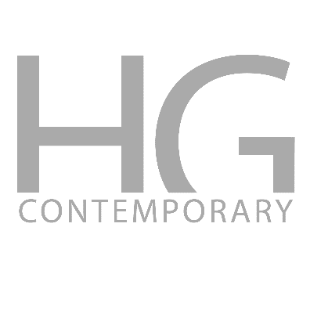
New York, NY – HG Contemporary is pleased to announce an exhibition of new work by AICAN + Ahmed Elgammal. Entitled Faceless Portraits Transcending in Time, the exhibition will run from February 12, 2019 through March 5, 2019.

Faceless Portraits Transcending in Time is a new venture into how artificial intelligence can transcend being a passive tool into becoming a partner unlocking creativity. The exhibition shows two series of works, both exploring the aesthetics of portraiture, when taking away meaning and context. In the first series, the artist used AI to explore the connection between classical portraits, with their ideal form, and contemporary photographic portraits, to the point where the portraits became abstract visual expressions that transcend time. In the second series the artist is exploring the reconstruction of visual form, from portraits into the realm of surrealism through exploring the connection between the classical and the contemporary, and between life and death.
Ahmed Elgammal is the founder and director of the Art and Artificial Intelligence Laboratory, and a professor of computer science at Rutgers University. He developed AICAN, an autonomous AI artist and collaborative creative partner. Dr. Elgammal’s research on knowledge discovery in art history and AI art generation, received wide international media attention, including reports on the Washington Post, New York Times, NBC News, CBS News, the Guardian, the Daily Telegraph, Science News, New Scientist, and many others. In 2017, an Artsy editorial acclaimed AICAN as “the biggest artistic achievement of the year”. In 2016, a TV segment about his research, produced for PBS, won an Emmy award. AICAN art has been shown in several technology and art venues in Los Angeles, Frankfurt, San Francisco, and New York City.
About HG Contemporary
Founded by Philippe Hoerle-Guggenheim, HG Contemporary is a breakthrough global gallery founded in 2014. The gallery has built a reputation for unearthing distinct artists and producing shows that embrace groundbreaking aesthetics and concepts. The gallery is committed to developing an international contemporary program that is ambitious as well as diverse. The gallery's locations include New York, Madrid, Napa Valley and Brooklyn. This commitment carries with it an innovative and clear vision about producing exceptional art exhibitions as well as a deep understanding of visual culture's function within and beyond the walls of the gallery. HG Contemporary has produced exhibitions featuring RETNA, Tim Bengel, Stuart McAlpine Miller, Conor McCreedy, Jason Dussault, Arsen Savadov, Mehwish Iqbal, Natvar Bhavsar among others.

A Word from the Founder, Philippe Hoerle-Guggenheim
"My love for art was passed on to me by my grand-mother and my mother. Both avid collectors, they instilled in me great admiration for the old masters, endless curiosity for the new and an insatiable appetite for the treasure hunt. Our house in Bonn, Germany, was always open to artists. There were visits to painters’ studios, trips to museums and constant art talk at the dinner table. I didn’t develop a formal education in art, I developed an instinct and a passion for it at a very young age. After graduating from Anglia Ruskin University, Cambridge, I went on to work as a financial analyst for Ernst & Young as well as The Hyatt Corporation and observed how trends move and impact our increasingly fast-paced society. During that time, I kept very close ties with the art community, hosting private events in the US and Europe. And as the art world became more dynamic, I found myself wanting to follow my own aesthetic compass and explore the incredible potential for renewal and audacity offered by new social interactions, digital technology and pop culture. This is how I came to create HG Contemporary at a captivating moment in art history. I feel truly lucky to be a part of it and to have built lasting relationships with some of the most provocative and raw talents of today." In addition to curating the gallery’s exhibitions, Philippe is actively engaged in numerous non-profit institutions including The Bowery Mission and as a board member of Elevate New York with the Bronx Studio School for Writers and Artists.

HG Contemporary hours are Tuesday through Saturday, 11am to 6pm. For further information please call 212.279.9219.

For Press Inquiries Contact:
Courtney Daniels
COURTNEY DANIELS CONSULTING
courtney@cocodanielsconsulting.com
www.courtneydanielsconsulting.com

